Team Page Administration Guide for Managers
Our website is powered by MBSportsWeb. This website is inter-active, user friendly and a great asset for each team.
MBSportsWeb has provided us a draft version of a Team Webmaster manual they created. It has a lot of great detailed information; in hopes to make it easier for the Managers, we have taken the parts that are most pertinent to the tasks we are asking Managers to complete.
If you have any questions, any suggestions – please email to webmaster@newcastlestars.com

Contents
1. Getting Website Access 3
2. Expectations for Updates 3
Update Team Home Page and Team News 3
Keep Player Rosters Updated 3
Keep Calendar Current 3
Automatically Added by NVMHA 3
Manager Added 3
3. Website Management 4
Accessing Control Panel 4
Adding Images 5
Newcastle Stars Logos 5
Adding a News Article 6
Adding Article Details 6
Saving Article 7
Modifying New Articles 8
Adding Events 8
Adding Event Details 8
Saving Event 8
Modifying Events 9
Update Player Rosters 9
Add Player Information 9
Add Team Photo 10
Add Coaches 10
Add Staff 10
Update Staff 10
Other Features 10

Getting Website Access
You should have received an email from Newcastle Village Minor Hockey with the link to login, your Username and Password. Once on the website, you can access the Control Panel on the top right-hand corner.
If you don’t have access or need a password reset contact webmaster@newcastlestars.com
You can designate a trusted person on your team to help you manage parts of your team page. Email the webmaster to have them setup.
See Accessing Control Panel

Expectations for Updates
These MINIMUM expectation of each Manager for your team’s page is the following:

Update Team Home Page and Team News
Update with player milestones (first goal, shutouts, hat tricks), pictures and media from games/tournaments, team events and fundraising. As an organization we want to celebrate these things! We want to share these accomplishments on social media, and we can’t do that if everything is trapped in WhatsApp or TeamSnap. If you need to designate a parent(s) from your team to make these posts, please let the webmaster know and they can set them up with access.

See Adding News Articles

Keep Player Rosters Updated
Update with position and jersey numbers. Add Email address for Manager and Head Coach mandatory.
Keep staff roster up to date.

See Updating Player Rosters

Keep Calendar Current

Automatically Added by NVMHA
- League Games
- NVMHA designated practice times for your team

Manager Added
- Tournaments
- Exhibition Games
- Extra practices booked by team
- Team Events
See Adding Events

Website Management
Updating the website cannot be done from mobile. You will need to do it from a desktop or laptop.

Accessing Control Panel
Enter the control panel from the main www.newcastlestars.com website:
- Login with username/password provided
- Click your name in the top right and select Control Panel
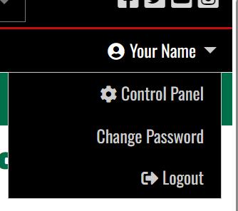
- Switch to Content view by clicking the “CONTENT” button on the top bar

Adding Images
When you add an image, you will get this Image Manager Dialogue:
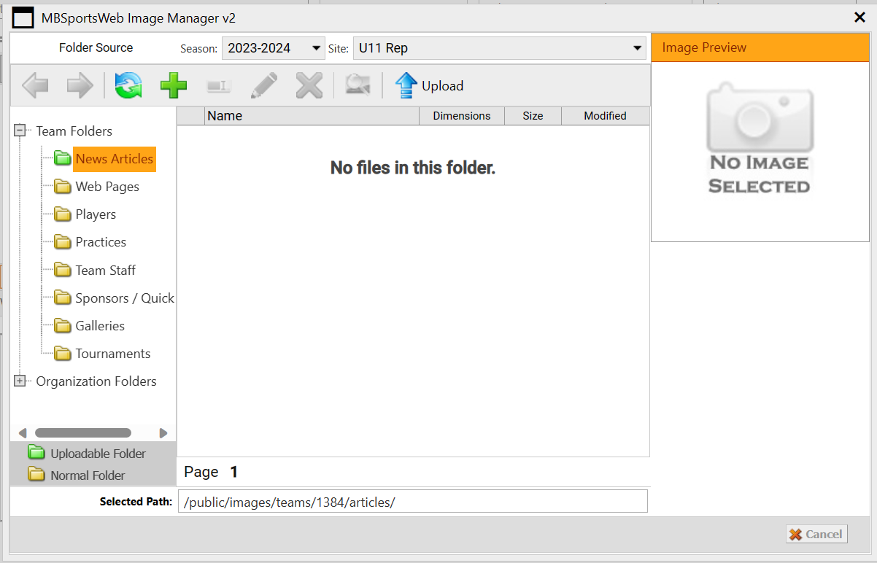

There is a list of folders under the Team Folders section on the left-hand side of the dialogue. Use these folders to organize your images.
To Upload an image first select the folder and then click the 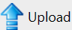 button on the tool bar.
From the Upload Images popup click 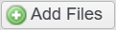 and select the files you want to add.
Once you have added all the files click 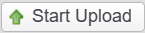
After the Upload is complete your files will be available to select and add to your article.

Newcastle Stars Logos
You can access the Newcastle Stars Logos from the Organization Folders under Organization Staff > Logos.
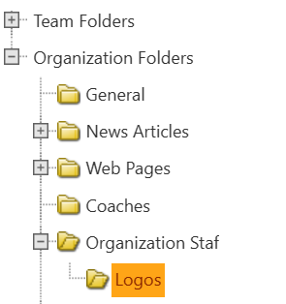

Adding a News Article
From the left-hand menu expand Manage Page Content and then click on Team Home Page.
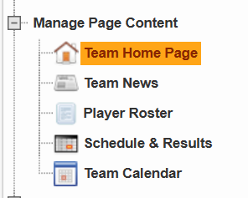
From the top bar select . This will bring up a dialogue box where you can fill in the details of your article.

Adding Article Details
To create a news article, you need to fill in information on two separate tabs. Below is the information you need to fill in on each tab to create a successful article.

Title, Date, & First Paragraph Tab
- Title - Give your article a fun title, this will be shown on the main page.
- Submit Date – Change this to a future date and it will be automatically posted at that time. Leave as default to automatically post when you are done. It’s also useful to change this date to a future date/time to save the article as a “draft” and then come back and change it to current date/time to post after it’s complete.
- First Paragraph – This is a one sentence high-level summary of the article. Keep it brief, something like “Results from our Car Wash Fundraiser!”. You will input the main article body in the Rest of The Article tab.
- Photo – Click on the button to open the image manager. Upload a photo that will be the title image for your post. This image will be shown with your article on the main page. You will have the ability to add more pictures in the next tab.
An example of what the article preview will look like, on the team page, with the info from this tab.

Rest of Article Tab
In this tab you will write the main body of your article. When the article is shown on the website it will include the “First Paragraph” above whatever you write here, so you don’t need to reiterate what you wrote in the previous tab.
Write your post and add images. Use the formatting tools to format your post how you see fit.

Saving Article
Once you are done adding your article content click the 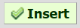 button in the bottom right of the dialogue window. If you had set the Submit Date in the Tile, Date, & First Paragraph tab to a future date/time then your article will show up on your Team’s page at that time. If the date is current or past the article will show up right away.

Modifying New Articles
From the Left-hand menu on the Content View expand Basic Features and select News Articles.
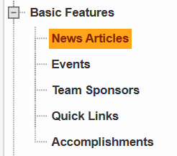
All of your news articles will be listed on the right-hand side of the screen. Double-click them to edit the details.

Adding Events
Events will show up on the team calendar on your team’s page.
From the left-hand menu expand Manage Page Content and then click on Team Home Page.
From the top bar select . This will bring up a dialogue box where you can fill in the details of your event.

Adding Event Details
There are two tabs you need to fill in to create the event.
Team Events will be visible on the team's home page as well as the team calendar. If you also want it to be visible on the organization pages, please contact your association webmaster who can mark it as a "major" event.

General Information Tab
- Event Title – Give your event an appropriate title.
- Location – Where is this event taking place?
- Starts/Ends – The timeframe of your event. For "All Day" Events, set the start time to be 12:00 AM and the end time to be 11:59 PM.

Additional Details Tab
Here you can fill in all the details about your event including pictures and links.

Saving Event
Once you are happy with your event you have two options to save:
- 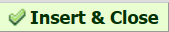 This will save your event and exit the dialogue back to Team Home Page.
- This will save your event and then keep the Event Dialogue open, with all your information still present. This is useful when adding multiple events of the same type as you can keep all relevant info the same while just modifying what is different such as dates or the title.

Modifying Events
From the Left-hand menu on the Content View expand Basic Features and select Events.
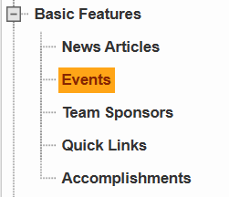
All of your events will be listed on the right-hand side of the screen. Double-click them to edit the details.

Update Player Rosters
From the left-hand menu expand Manage Page Content and then click on Player Roster.
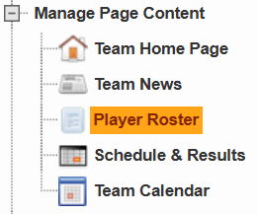

Add Player Information
Double click any player in the Player Roster section to bring up a Player Information dialogue box. Complete all required information.

General Tab
- Jersey – The player’s jersey number
- Position(s) – Which positions does this player play?
- Shoots – Which way does this player shoot?

Bio & Photo Tab
- Photo (optional) – Click to add a photo of this player that will be shown on the team’s roster page
- Bio (optional) – write a short bio for the player

Save
Click to update this player’s information

Add Team Photo
Double-click inside the Team Photo section box to bring up the Team Photo & Description dialogue box.
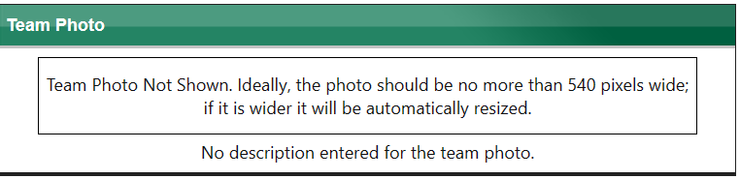
Photo Tab
Click to open the Image Manger which will allow you to upload a team phone and select it.

Save
Click to save your team photo selection.

Add Coaches
Coaches are added by the NVMHA webmaster. If we missed a coach, please email webmaster@newcastlestars.com.

Add Staff
In the top bar click
Fill in all the details about the staff member.

Mandatory fields
- Role – Select from list or type in one that is not listed.
- First Name
- Last Name
- Email Address

Save
Click to save the staff member.

Update Staff
Double click the staff member’s name on the Player Roster screen to bring up their information.

Other Features
From the Left-hand menu on the Content View expand Basic Features to view all these items. Feel free to click on all of them and explore.

- News Articles – Team news articles allow you to post information about things that your team has already done (like game recaps, tournament recaps, etc.) or things that your team has coming up (like playoff series, tournaments, etc.). By default, news articles will show up on your team’s website, on the home page as well as in the news archive page.
The News Article form contains 2 tabs: “Title, Date & First Paragraph”, and “Rest of the Article”.
- Events – Events can be added for your team to indicate things that are happening for your team which have a specific date range. All REP games and practices are entered by NVMHAI Scheduler. You can add additional practices and exhibition games arranged by your Coach.
- Team Sponsors – Add a sponsor for your team.
- Quick links – You can add any links you feel may benefit your team. The home page has quick links as well.
- Accomplishments – Team accomplishments are similar to news articles, you can report these in either section, it’s up to you.

